

**Awns’s store**

**(Laptop & Phone)**

**Software Design Specification**

**Team 1**

– Hanoi, Feb 2023 –

Record of changeS

|  |  |  |  |
| --- | --- | --- | --- |
| Date | A* M, D | In charge | Change Description |
| 17/2 | A | GiangNXT | Add Database Design (I.2) |
| 25/2 | A | GiangNXT | Add Code Design (II.1, II.2, II.3) |
| 26/2 | M | GiangNXT | Modified Code Design (II.3, II.4) |
| 2/3 | M | GiangNXT | Modified Code Design (II.1, II.2, II.3, II.4), Database Design (I.2) |
| 3/3 | A | GiangNXT | Add Code Design (II.5, II.6, II.7, II.8, II.9, II.10) |
|  |  |  |  |
|  |  |  |  |
|  |  |  |  |
|  |  |  |  |
|  |  |  |  |
|  |  |  |  |
|  |  |  |  |
|  |  |  |  |

*A - Added M - Modified D - Deleted

**Table of Contents**

I. Overview 5

1. Code Packages 5

2. Database Design 5

II. Code Designs 6

1. Home Page – Display Product Lists 6

2. Product List - Filter 8

3. Search Order 11

4. Login for Customer 13

5. Login for Employee 16

6. Log out 17

7. Sign up user 18

8. Edit Profile 20

9. Product Details 22

10. Display Profile 25

# I. Overview

## 1. Code Packages

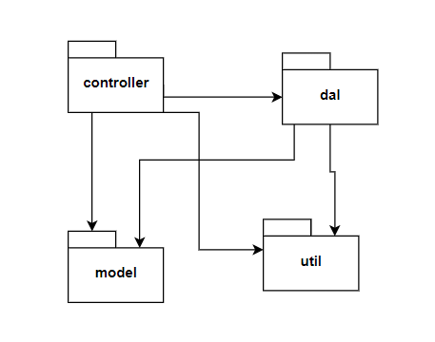

***Package descriptions***

|  |  |  |
| --- | --- | --- |
| **No** | **Package** | **Description** |
| 1 | Controller | Data processing and navigate to jsp |
| 2 | Dal | Interact with data base |
| 3 | Model | Include objectives |
| 4 | Util | Function to support data processing |

## 2. Database Design

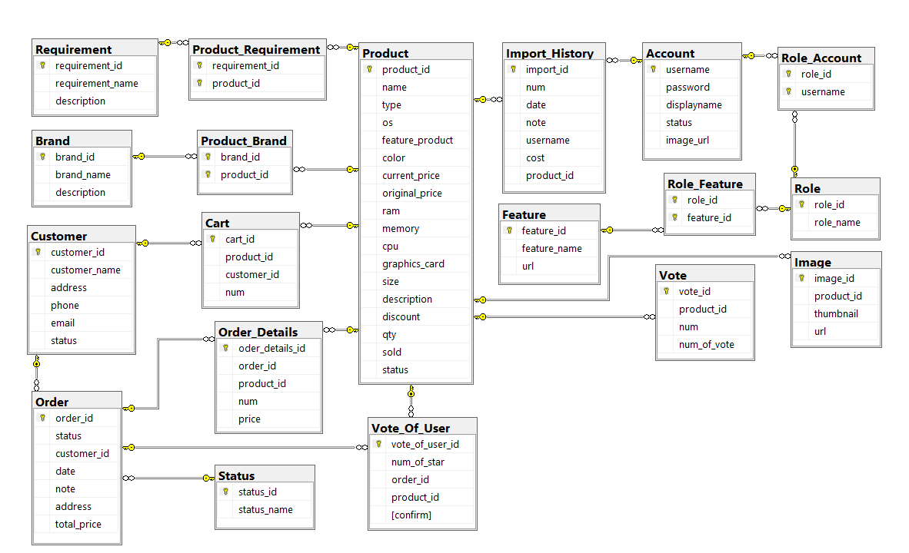

# II. Code Designs

## 1. Home Page – Display Product Lists

a. Class Diagram

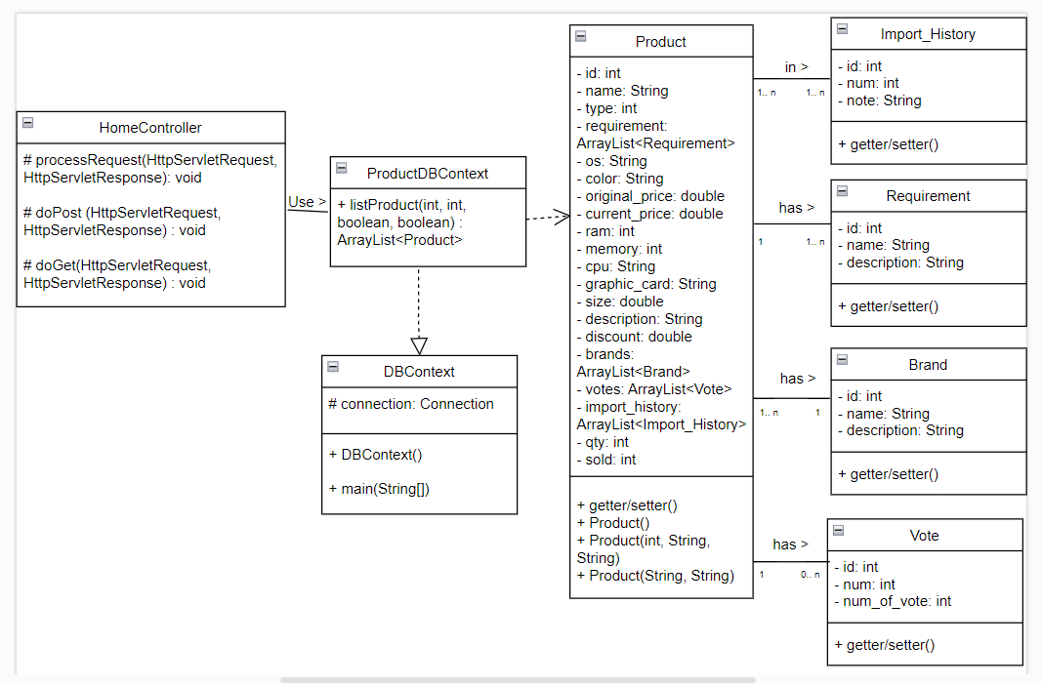

b. Class Specifications

#### HomeController

***Class Methods***

|  |  |  |
| --- | --- | --- |
| **No** | **Method** | **Description** |
| 01 | processRequest(HttpServletRequest, HttpServletResponse): void | To handle request, get data from database and display to jsp |
| 02 | doPost(HttpServletRequest, HttpServletResponse): void | Call processRequest(HttpServletRequest, HttpServletResponse) |
| 03 | doGet(HttpServletRequest, HttpServletResponse): void | Call processRequest(HttpServletRequest, HttpServletResponse) |

#### ProductDBContext

***Class Methods***

|  |  |  |
| --- | --- | --- |
| **No** | **Method** | **Description** |
| 01 | listProduct(int, int, boolean, boolean): ArrayList<Product> | Get list of product base on: what type? (phone or laptop), how much? (number of product), Is top of sale? Is top of sold? |

#### DBContext

***Class Methods***

|  |  |  |
| --- | --- | --- |
| **No** | **Method** | **Description** |
| 01 | DBContext() | To connect with database |
| 02 | main(String[]) | Call DBContext() |

c. Sequence Diagram(s)

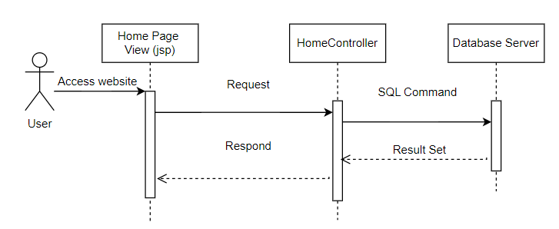

d. Database Queries

//Select top 8 of best-seller

SELECT TOP 8 [PRODUCT_ID], [NAME], [TYPE], [OS], [COLOR], [CURRENT_PRICE]

, [ORIGINAL_PRICE], [RAM], [MEMORY], [CPU], [GRAPHICS_CARD]

, [SIZE], [DESCRIPTION], [DISCOUNT], [QTY], [SOLD], [STATUS]

FROM [PRODUCT] WHERE [STATUS] = 1

ORDER BY [SOLD] DESC

//Select top 8 of promotional product

SELECT TOP 8 [PRODUCT_ID], [NAME], [TYPE], [OS], [COLOR], [CURRENT_PRICE]

, [ORIGINAL_PRICE], [RAM], [MEMORY], [CPU], [GRAPHICS_CARD]

, [SIZE], [DESCRIPTION], [DISCOUNT], [QTY], [SOLD], [STATUS]

FROM [PRODUCT] WHERE [STATUS] = 1

ORDER BY [DISCOUNT] DESC

// Select first of 8 phones

SELECT TOP 8 [PRODUCT_ID], [NAME], [TYPE], [OS], [COLOR], [CURRENT_PRICE]

, [ORIGINAL_PRICE], [RAM], [MEMORY], [CPU], [GRAPHICS_CARD]

, [SIZE], [DESCRIPTION], [DISCOUNT], [QTY], [SOLD], [STATUS]

FROM [PRODUCT] WHERE [STATUS] = 1 AND [TYPE] = 0

//Select first of 8 laptops

SELECT TOP 8 [PRODUCT_ID], [NAME], [TYPE], [OS], [COLOR], [CURRENT_PRICE]

, [ORIGINAL_PRICE], [RAM], [MEMORY], [CPU], [GRAPHICS_CARD]

, [SIZE], [DESCRIPTION], [DISCOUNT], [QTY], [SOLD], [STATUS]

FROM [PRODUCT] WHERE [STATUS] = 1 AND [TYPE] = 1

## 2. Product List - Filter

a. Class Diagram

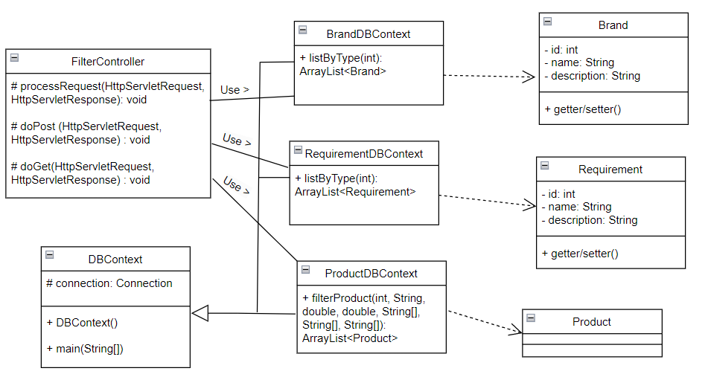

b. Class Specifications

#### DBContext

***Class Methods***

|  |  |  |
| --- | --- | --- |
| **No** | **Method** | **Description** |
| 01 | DBContext() | To connect with database |
| 02 | main(String[]) | Call DBContext() |

#### FilterController

***Class Methods***

|  |  |  |
| --- | --- | --- |
| **No** | **Method** | **Description** |
| 01 | processRequest(HttpServletRequest, HttpServletResponse): void | To handle request, get data from database and display to jsp |
| 02 | doPost(HttpServletRequest, HttpServletResponse): void | Call processRequest(HttpServletRequest, HttpServletResponse) |
| 03 | doGet(HttpServletRequest, HttpServletResponse): void | Call processRequest(HttpServletRequest, HttpServletResponse) |

#### BrandDBContext

***Class Methods***

|  |  |  |
| --- | --- | --- |
| **No** | **Method** | **Description** |
| 01 | listByType(int): ArrayList<Brand> | Get list of brands by category product (phone or laptop) |

#### RequirementDBContext

***Class Methods***

|  |  |  |
| --- | --- | --- |
| **No** | **Method** | **Description** |
| 01 | listByType(int): ArrayList<Requirement> | Get list of requirements by category product (phone or laptop) |

#### ProductDBContext

***Class Methods***

|  |  |  |
| --- | --- | --- |
| **No** | **Method** | **Description** |
| 01 | filterProduct(int, String, double, double, String[], String[], String[]): ArrayList<Product> | Get list of products by filter |

c. Sequence Diagram(s)

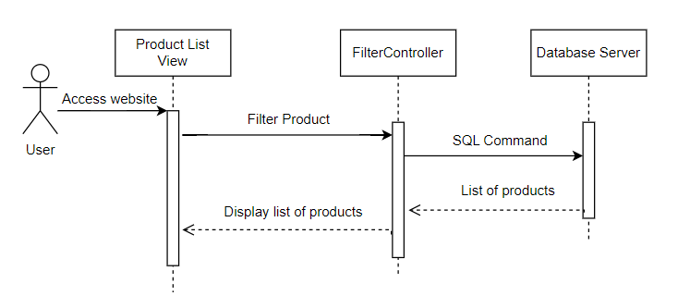

d. Database Queries

//Select all brand of laptop or iphone

SELECT DISTINCT B.[BRAND_ID], B.[BRAND_NAME], B.[DESCRIPTION]

FROM [BRAND] B

INNER JOIN PRODUCT_BRAND PB ON PB.BRAND_ID = B.BRAND_ID

INNER JOIN PRODUCT PR ON PR.PRODUCT_ID = PB.PRODUCT_ID

WHERE PR.[TYPE] =?

//Select all requirement of laptop or iphone

SELECT DISTINCT P.[REQUIREMENT_ID], P.[REQUIREMENT_NAME], P.[DESCRIPTION]

FROM [REQUIREMENT] P

INNER JOIN PRODUCT_REQUIREMENT PR

ON PR.REQUIREMENT_ID = P.REQUIREMENT_ID

INNER JOIN PRODUCT PRD ON PRD.PRODUCT_ID = PR.PRODUCT_ID

WHERE PRD.[TYPE] = ?

//Select all product match with filter

SELECT DISTINCT PR.[PRODUCT_ID], PR.[NAME], PR.[TYPE], PR.[OS], PR.[FEATURE_PRODUCT]

, PR.[COLOR], PR.[CURRENT_PRICE], PR.[ORIGINAL_PRICE], PR.[RAM]

, PR.[MEMORY], PR.[CPU], PR.[GRAPHICS_CARD], PR.[SIZE], PR.[DESCRIPTION]

, PR.[DISCOUNT], PR.[QTY], PR.[SOLD], PR.[STATUS]

FROM [PRODUCT] PR

INNER JOIN [PRODUCT_BRAND] PRBR ON PR.PRODUCT_ID = PRBR.PRODUCT_ID

INNER JOIN [BRAND] BR ON PRBR.BRAND_ID = BR.BRAND_ID

INNER JOIN [PRODUCT_REQUIREMENT] PRRE

ON PR.PRODUCT_ID = PRRE.PRODUCT_ID

INNER JOIN [REQUIREMENT] RE

ON PRRE.REQUIREMENT_ID =RE.REQUIREMENT_ID

WHERE PR.[STATUS] = 1

AND PR.[CURRENT_PRICE] >= ?

AND PR.[CURRENT_PRICE] <= ?

AND PR.[TYPE] = ?

## 3. Search Order

a. Class Diagram

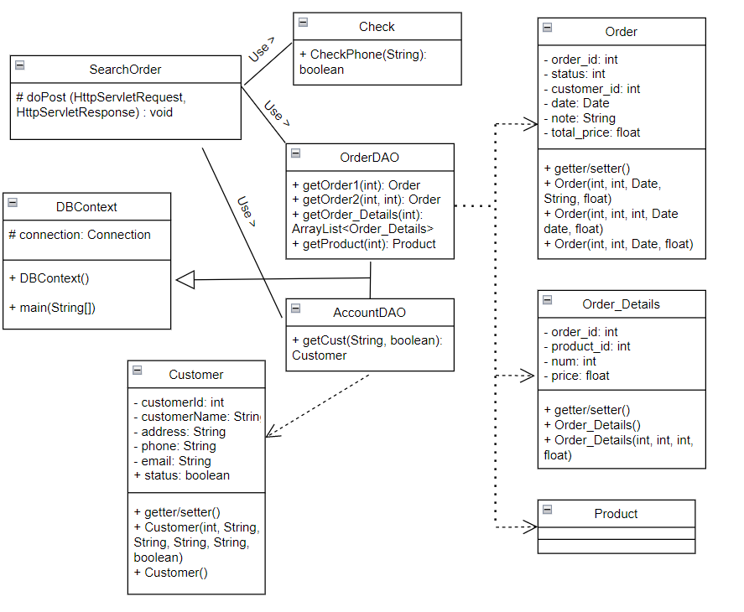

b. Class Specifications

#### DBContext

***Class Methods***

|  |  |  |
| --- | --- | --- |
| **No** | **Method** | **Description** |
| 01 | DBContext() | To connect with database |
| 02 | main(String[]) | Call DBContext() |

#### Check

***Class Methods***

|  |  |  |
| --- | --- | --- |
| **No** | **Method** | **Description** |
| 01 | CheckPhone(String): boolean | Validate input is number or not |

#### OrderDAO

***Class Methods***

|  |  |  |
| --- | --- | --- |
| **No** | **Method** | **Description** |
| 01 | getOrder1(int): Order | Get order by order id |
| 02 | getOrder2(int, int): Order | Get order by order id and customer id |
| 03 | getOrder_Details(int):  ArrayList<Order_Details> | Get list of Order Details by order id |
| 04 | getProduct(int): Product | Get product by product id |

AccountDAO

***Class Methods***

|  |  |  |
| --- | --- | --- |
| **No** | **Method** | **Description** |
| 01 | getCust(String, boolean): Customer | Get Customer by email and status |

#### SearchOrder

***Class Methods***

|  |  |  |
| --- | --- | --- |
| **No** | **Method** | **Description** |
| 01 | doPost (HttpServletRequest, HttpServletResponse): void | Handle request by doPost method |

c. Sequence Diagram(s)

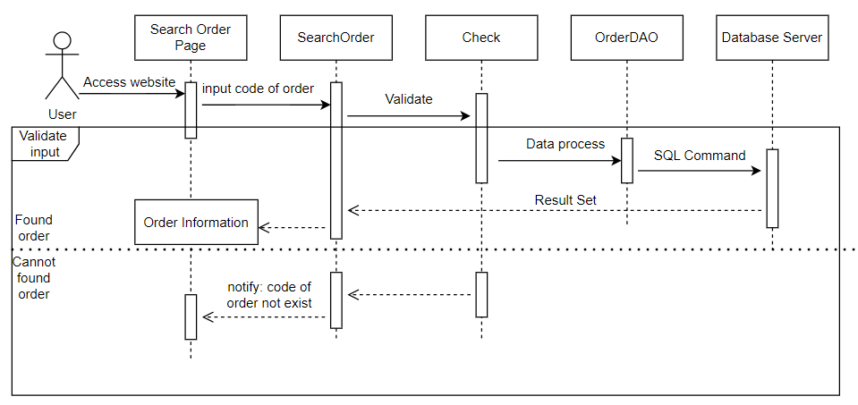

d. Database Queries

//Select order by order id

SELECT * FROM [ORDER] WHERE ORDER_ID = ?

//Select order by order id and customer id

SELECT * FROM [ORDER] WHERE ORDER_ID = ? AND CUSTOMER_ID = ?

//Select Order Details by order id

SELECT * FROM ORDER_DETAILS WHERE ORDER_ID =?

//Select product by product id

SELECT [NAME],COLOR FROM PRODUCT WHERE PRODUCT_ID = ?

//Select Customer by email and status

SELECT [CUSTOMER_ID], [CUSTOMER_NAME], [ADDRESS], [PHONE], [EMAIL], [STATUS]

FROM [DBO].[CUSTOMER]

WHERE [EMAIL] = ? AND STATUS =?

## 4. Login for Customer

a. Class Diagram

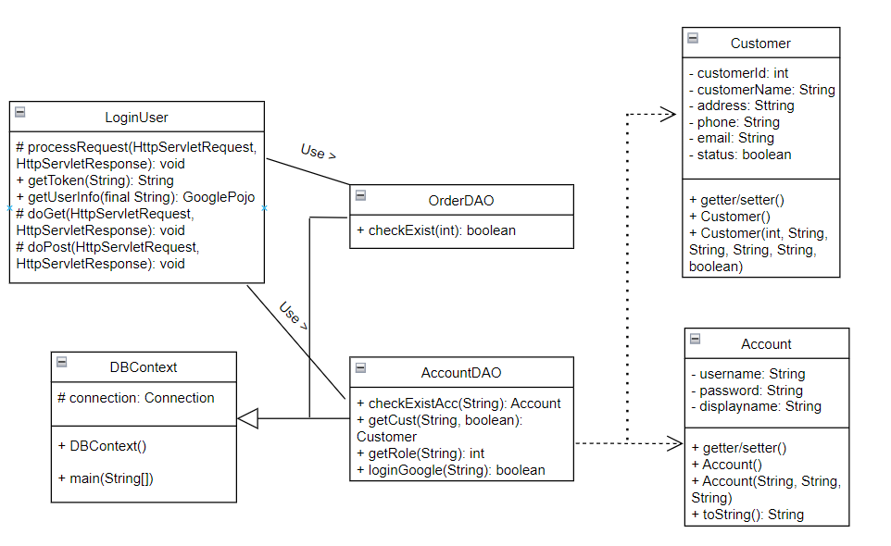

b. Class Specifications

#### DBContext

***Class Methods***

|  |  |  |
| --- | --- | --- |
| **No** | **Method** | **Description** |
| 01 | DBContext() | To connect with database |
| 02 | main(String[]) | Call DBContext() |

#### LoginUser

***Class Methods***

|  |  |  |
| --- | --- | --- |
| **No** | **Method** | **Description** |
| 01 | processRequest(HttpServletRequest, HttpServletResponse): void | Handle request |
| 02 | doPost(HttpServletRequest, HttpServletResponse): void | Call processRequest(HttpServletRequest, HttpServletResponse) |
| 03 | doGet(HttpServletRequest, HttpServletResponse): void | Call processRequest(HttpServletRequest, HttpServletResponse) |
| 04 | getToken(String): String | Compile code from respond of google and send Verification Code back |
| 05 | getUserInfo(final String): GooglePojo | Get information of user from google |

#### OrderDAO

***Class Methods***

|  |  |  |
| --- | --- | --- |
| **No** | **Method** | **Description** |
| 01 | checkExist(int): boolean | Check user account has cart or not |

#### AccountDAO

***Class Methods***

|  |  |  |
| --- | --- | --- |
| **No** | **Method** | **Description** |
| 01 | checkExistAcc(String): Account | Check and get Account by username |
| 02 | getCust(String, boolean): Customer | Get customer information by email and status |
| 03 | getRole(String): int | Get role of account |
| 04 | loginGoogle(String): boolean | Check email exist in database or not |

c. Sequence Diagram(s)

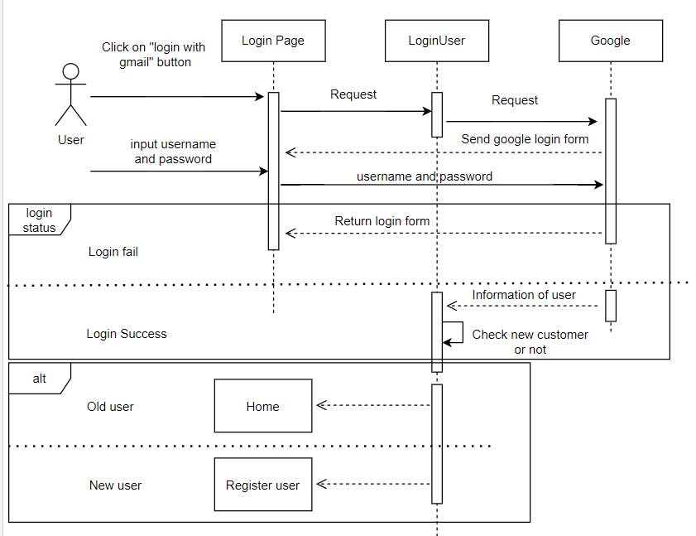

d. Database Queries

//Select account by username

SELECT * FROM ACCOUNT WHERE USERNAME =?

//Select customer by email and status

SELECT [CUSTOMER_ID], [CUSTOMER_NAME], [ADDRESS], [PHONE], [EMAIL], [STATUS]

FROM [DBO].[CUSTOMER]

WHERE [EMAIL] = ? AND STATUS =?

//Select role id by username

SELECT ROLE_ID FROM ROLE_ACCOUNT WHERE USERNAME = ?

//Select cart id by customer id

SELECT CART_ID FROM CART WHERE CUSTOMER_ID = ?

//Select customer information by email

SELECT [CUSTOMER_ID], [CUSTOMER_NAME], [ADDRESS], [PHONE], [EMAIL], [STATUS]

FROM [DBO].[CUSTOMER]

WHERE [EMAIL] = ?

## 5. Login for Employee

a. Class Diagram

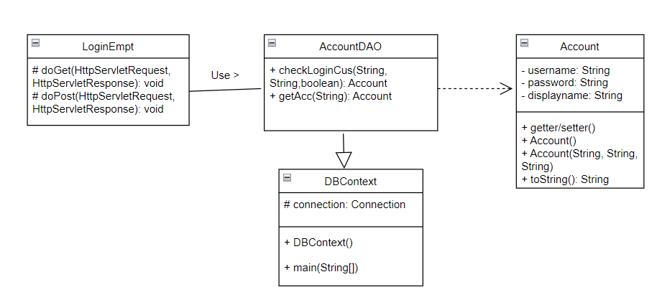

b. Class Specifications

#### DBContext

***Class Methods***

|  |  |  |
| --- | --- | --- |
| **No** | **Method** | **Description** |
| 01 | DBContext() | To connect with database |
| 02 | main(String[]) | Call DBContext() |

#### AccountDAO

***Class Methods***

|  |  |  |
| --- | --- | --- |
| **No** | **Method** | **Description** |
| 01 | checkLoginCus(String, String,boolean): Account | Check username and password |
| 02 | getAcc(String): Account | Get account has specific username |

#### LoginEmpt

***Class Methods***

|  |  |  |
| --- | --- | --- |
| **No** | **Method** | **Description** |
| 01 | doPost(HttpServletRequest, HttpServletResponse): void | Handle request with Post method |
| 02 | doGet(HttpServletRequest, HttpServletResponse): void | Handle request with Get method |

c. Sequence Diagram(s)

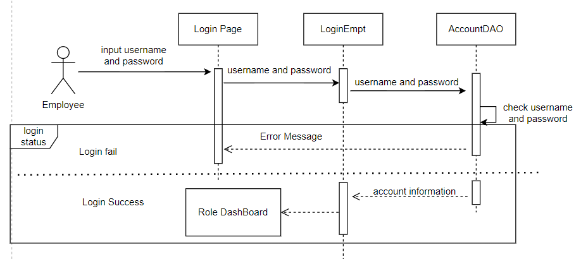

d. Database Queries

//select account has specific username and password

SELECT * FROM ACCOUNT WHERE USERNAME =? AND PASSWORD=? AND [STATUS] =1

//select information of account has specific username

SELECT * FROM ACCOUNT INNER JOIN ROLE_ACCOUNT ON ACCOUNT.USERNAME = ROLE_ACCOUNT.USERNAME WHERE ACCOUNT.USERNAME= ? AND ACCOUNT.STATUS = 1

## 6. Log out

a. Class Diagram

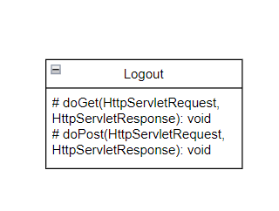

b. Class Specifications

#### Logout

***Class Methods***

|  |  |  |
| --- | --- | --- |
| **No** | **Method** | **Description** |
| 01 | doPost(HttpServletRequest, HttpServletResponse): void | Handle request with Post method |
| 02 | doGet(HttpServletRequest, HttpServletResponse): void | Handle request with Get method |

c. Sequence Diagram(s)

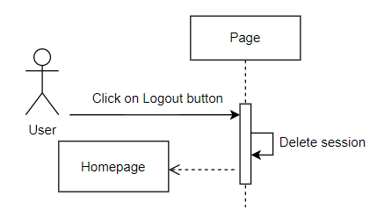

## 7. Sign up user

a. Class Diagram

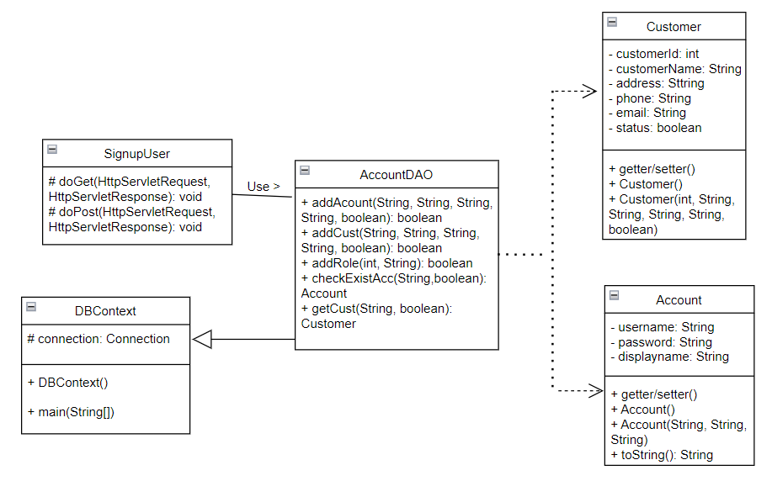

b. Class Specifications

#### DBContext

***Class Methods***

|  |  |  |
| --- | --- | --- |
| **No** | **Method** | **Description** |
| 01 | DBContext() | To connect with database |
| 02 | main(String[]) | Call DBContext() |

#### SignupUser

***Class Methods***

|  |  |  |
| --- | --- | --- |
| **No** | **Method** | **Description** |
| 01 | doPost(HttpServletRequest, HttpServletResponse): void | Handle request with Post method |
| 02 | doGet(HttpServletRequest, HttpServletResponse): void | Handle request with Get method |

#### AccountDAO

***Class Methods***

|  |  |  |
| --- | --- | --- |
| **No** | **Method** | **Description** |
| 01 | addAcount(String, String, String, String, boolean): boolean | Add account information to database |
| 02 | addCust(String, String, String, String, boolean): boolean | Add customer information to database |
| 03 | addRole(int, String): boolean | Add role for specific account |
| 04 | checkExistAcc(String,boolean): Account | Get specific account from database |
| 05 | getCust(String, boolean): Customer | Get customer by account |

c. Sequence Diagram(s)

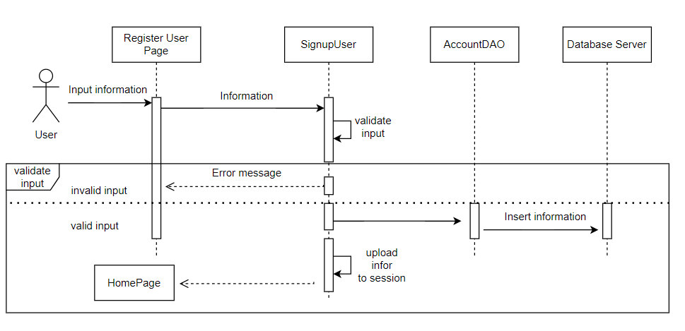

d. Database Queries

//insert new account

INSERT INTO ACCOUNT

(USERNAME,PASSWORD,DISPLAYNAME,[STATUS],IMAGE_URL) VALUES (?,?,?,?,?)

//insert new customer

INSERT INTO CUSTOMER

(CUSTOMER_NAME,ADDRESS,PHONE,EMAIL,[STATUS]) VALUES (?,?,?,?,?)

//add role to account

INSERT INTO ROLE_ACCOUNT

(ROLE_ID,USERNAME) VALUES(?,?)

//select account by specific username

SELECT * FROM ACCOUNT

WHERE USERNAME =? AND [STATUS] = 1

//select customer information by email

SELECT [CUSTOMER_ID]

,[CUSTOMER_NAME]

,[ADDRESS]

,[PHONE]

,[EMAIL],[STATUS]

FROM [DBO].[CUSTOMER]

WHERE [EMAIL] = ? AND STATUS =?

## 8. Edit Profile

a. Class Diagram

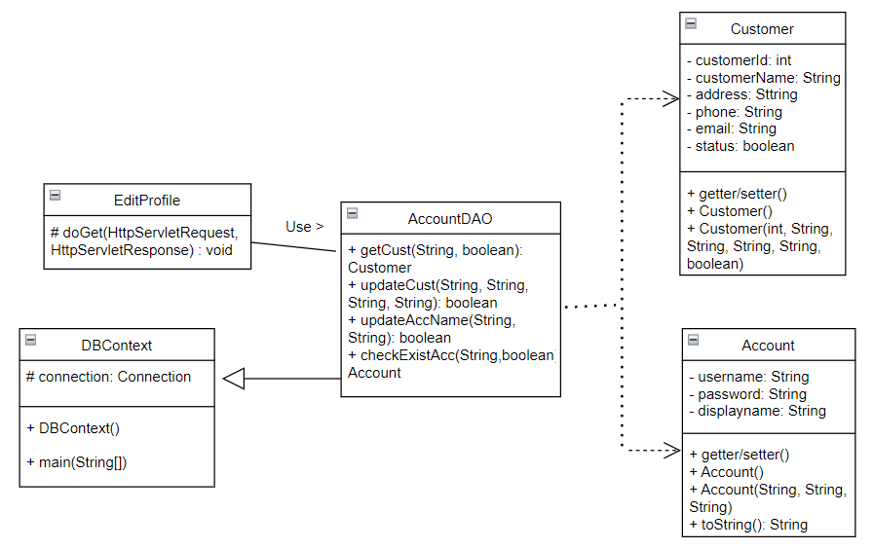

b. Class Specifications

#### DBContext

***Class Methods***

|  |  |  |
| --- | --- | --- |
| **No** | **Method** | **Description** |
| 01 | DBContext() | To connect with database |
| 02 | main(String[]) | Call DBContext() |

#### EditProfile

***Class Methods***

|  |  |  |
| --- | --- | --- |
| **No** | **Method** | **Description** |
| 01 | doGet(HttpServletRequest, HttpServletResponse): void | Handle request with Get method |

#### AccountDAO

***Class Methods***

|  |  |  |
| --- | --- | --- |
| **No** | **Method** | **Description** |
| 01 | getCust(String, boolean): Customer | Get customer by email |
| 02 | updateCust(String, String, String, String): boolean | Update information of customer |
| 03 | updateAccName(String, String): boolean | Update display name of account |
| 04 | checkExistAcc(String,boolean): Account | Get account by username |

c. Sequence Diagram(s)

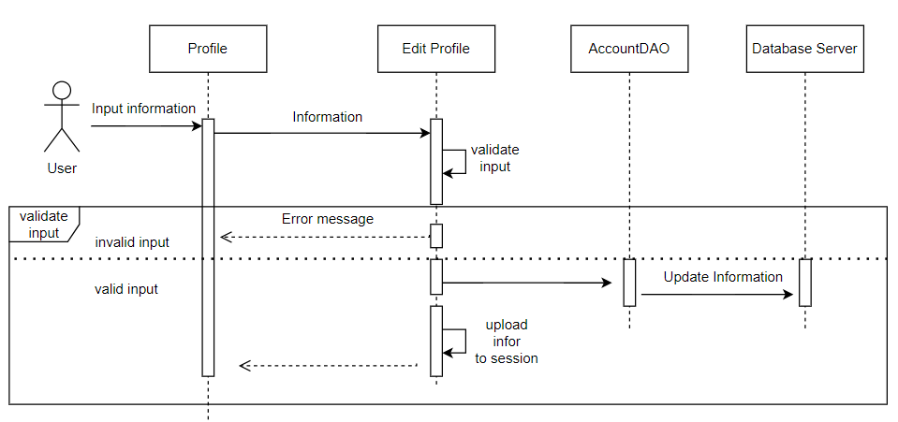

d. Database Queries

//Update customer information

UPDATE CUSTOMER

SET CUSTOMER_NAME = ? ,ADDRESS = ? ,PHONE = ? WHERE EMAIL = ?

//Update displayname of account

UPDATE ACCOUNT SET DISPLAYNAME = ? WHERE USERNAME = ?

//select customer information by email

SELECT [CUSTOMER_ID]

,[CUSTOMER_NAME]

,[ADDRESS]

,[PHONE]

,[EMAIL],[STATUS]

FROM [DBO].[CUSTOMER]

WHERE [EMAIL] = ? AND STATUS =?

//select account information by username

SELECT *

FROM ACCOUNT

WHERE USERNAME =? AND [STATUS] = 1

## 9. Product Details

a. Class Diagram

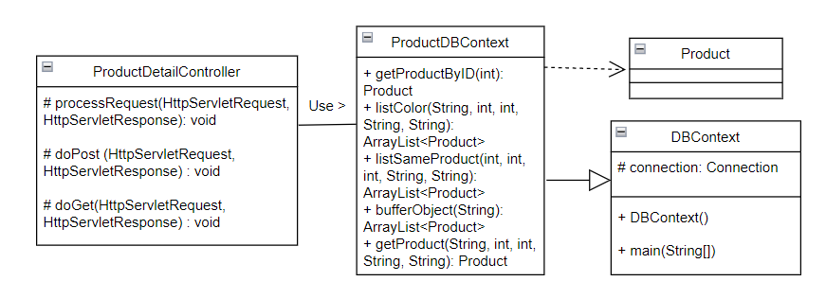

b. Class Specifications

#### DBContext

***Class Methods***

|  |  |  |
| --- | --- | --- |
| **No** | **Method** | **Description** |
| 01 | DBContext() | To connect with database |
| 02 | main(String[]) | Call DBContext() |

#### ProductDetailController

***Class Methods***

|  |  |  |
| --- | --- | --- |
| **No** | **Method** | **Description** |
| 01 | processRequest(HttpServletRequest, HttpServletResponse): void | To handle request, get data from database and display to jsp |
| 02 | doPost(HttpServletRequest, HttpServletResponse): void | Call processRequest(HttpServletRequest, HttpServletResponse) |
| 03 | doGet(HttpServletRequest, HttpServletResponse): void | Call processRequest(HttpServletRequest, HttpServletResponse) |

#### ProductDBContext

***Class Methods***

|  |  |  |
| --- | --- | --- |
| **No** | **Method** | **Description** |
| 01 | getProductByID(int): Product | Get Product by Product id |
| 02 | listColor(String, int, int, String, String): ArrayList<Product> | Get list of same products with difference color |
| 03 | listSameProduct(int, int, int, String, String): ArrayList<Product> | Get list of product same with specific product |
| 04 | bufferObject(String): ArrayList<Product> | Get list of product have same name with specific product |
| 05 | getProduct(String, int, int, String, String): Product | Get product with specific information |

c. Sequence Diagram(s)

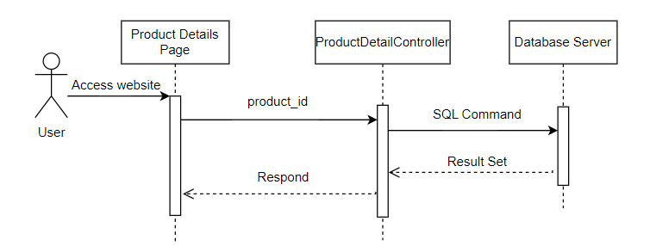

d. Database Queries

//select product by product id

SELECT [PRODUCT_ID],[NAME],[TYPE],[OS],[COLOR],[CURRENT_PRICE],[ORIGINAL_PRICE],[RAM]

,[MEMORY],[CPU],[GRAPHICS_CARD],[SIZE],[DESCRIPTION],[DISCOUNT],[QTY]

,[SOLD],[STATUS]

FROM [PRODUCT] WHERE [STATUS] = 1 AND [PRODUCT_ID] = ?

//select same product with difference color

SELECT DISTINCT PR.[PRODUCT_ID],PR.[NAME],PR.[TYPE],PR.[OS],PR.[FEATURE_PRODUCT],PR.[COLOR]

,PR.[CURRENT_PRICE],PR.[ORIGINAL_PRICE],PR.[RAM],PR.[MEMORY],PR.[CPU]

,PR.[GRAPHICS_CARD] ,PR.[SIZE],PR.[DESCRIPTION],PR.[DISCOUNT],PR.[QTY],PR.[SOLD]

,PR.[STATUS]

FROM [PRODUCT] PR

WHERE PR.[STATUS] = 1 AND PR.[NAME] LIKE ?

AND PR.[RAM] LIKE ? AND PR.[MEMORY] LIKE ? AND PR.[CPU] LIKE ? AND PR.[GRAPHICS_CARD] LIKE ?

//select same product

SELECT DISTINCT TOP (?) PR.[PRODUCT_ID],PR.[NAME],PR.[TYPE],PR.[OS],PR.[FEATURE_PRODUCT],PR.[COLOR]

,PR.[CURRENT_PRICE],PR.[ORIGINAL_PRICE],PR.[RAM],PR.[MEMORY],PR.[CPU]

,PR.[GRAPHICS_CARD],PR.[SIZE],PR.[DESCRIPTION],PR.[DISCOUNT],PR.[QTY],PR.[SOLD]

,PR.[STATUS]

FROM [PRODUCT] PR

WHERE PR.[STATUS] = 1

AND PR.[RAM] LIKE ? AND PR.[MEMORY] LIKE ? AND PR.[CPU] LIKE ? AND PR.[GRAPHICS_CARD] LIKE ?

//select product with same name

SELECT DISTINCT

PR.[NAME] ,PR.[RAM],PR.[MEMORY]

,PR.[CPU],PR.[GRAPHICS_CARD]

FROM [PRODUCT] PR

WHERE PR.[STATUS] = 1 AND PR.[NAME] LIKE ?

//select product have specific information

SELECT TOP (1) [PRODUCT_ID],[NAME],[TYPE],[OS],[COLOR],[CURRENT_PRICE],[ORIGINAL_PRICE],[RAM],[MEMORY]

,[CPU],GRAPHICS_CARD],[SIZE],[DESCRIPTION],[DISCOUNT],[QTY],[SOLD],[STATUS]

FROM [PRODUCT]

WHERE [STATUS] = 1 AND [NAME] LIKE ?

AND [RAM] LIKE ? AND [MEMORY] LIKE ? AND [CPU] LIKE ? AND [GRAPHICS_CARD] LIKE ?

## 10. Add to Cart

a. Class Diagram

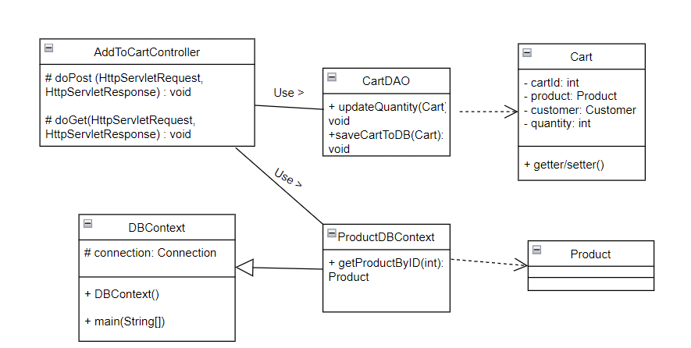

b. Class Specifications

#### DBContext

***Class Methods***

|  |  |  |
| --- | --- | --- |
| **No** | **Method** | **Description** |
| 01 | DBContext() | To connect with database |
| 02 | main(String[]) | Call DBContext() |

#### AddToCartController

***Class Methods***

|  |  |  |
| --- | --- | --- |
| **No** | **Method** | **Description** |
| 01 | doGet(HttpServletRequest, HttpServletResponse): void | Handle request with Get method |
| 02 | doPost(HttpServletRequest, HttpServletResponse): void | Handle request with Post method |

#### CartDAO

***Class Methods***

|  |  |  |
| --- | --- | --- |
| **No** | **Method** | **Description** |
| 01 | updateQuantity(Cart): void | Update quantity in specific cart |
| 02 | saveCartToDB(Cart): void | Save cart to database |

#### ProductDBContext

***Class Methods***

|  |  |  |
| --- | --- | --- |
| **No** | **Method** | **Description** |
| 01 | getProductByID(int): Product | Get Product by Product ID |

c. Sequence Diagram(s)

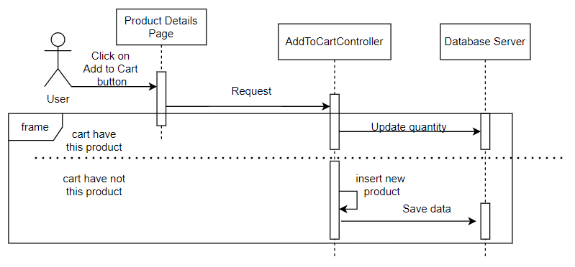

d. Database Queries

//update quantity of product in specific cart

UPDATE [DBO].[CART]

SET [PRODUCT_ID] = ?

,[CUSTOMER_ID] = ?

,[NUM] = ?

WHERE PRODUCT_ID = ? AND CUSTOMER_ID = ?

//insert new cart

INSERT INTO [DBO].[CART]

([PRODUCT_ID],[CUSTOMER_ID],[NUM])

VALUES (?, ?, ?)

//select product by specific information

SELECT TOP (1) [PRODUCT_ID],[NAME],[TYPE],[OS],[COLOR],[CURRENT_PRICE],[ORIGINAL_PRICE],[RAM],[MEMORY]

,[CPU],GRAPHICS_CARD],[SIZE],[DESCRIPTION],[DISCOUNT],[QTY],[SOLD],[STATUS]

FROM [PRODUCT]

WHERE [STATUS] = 1 AND [NAME] LIKE ?

AND [RAM] LIKE ? AND [MEMORY] LIKE ? AND [CPU] LIKE ? AND [GRAPHICS_CARD] LIKE ?

## 11. My Cart (Remove a product, Remove all product)

a. Class Diagram

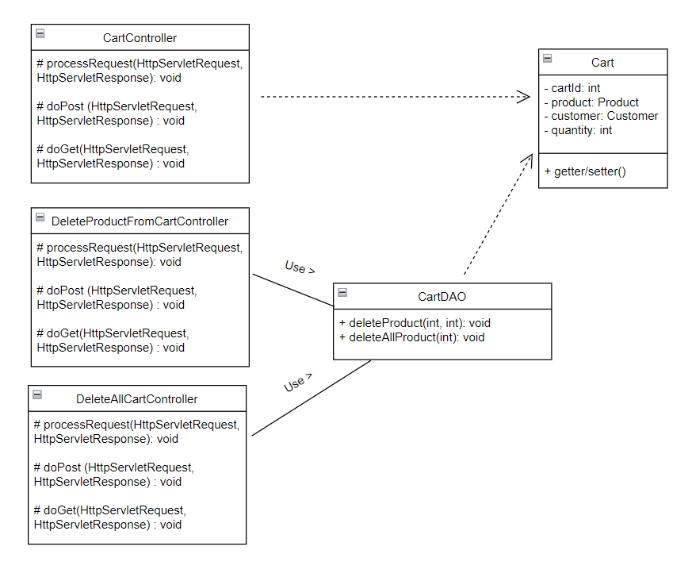

b. Class Specifications

#### CartController

***Class Methods***

|  |  |  |
| --- | --- | --- |
| **No** | **Method** | **Description** |
| 01 | processRequest(HttpServletRequest, HttpServletResponse): void | To handle request, get data from database and display to jsp |
| 02 | doPost(HttpServletRequest, HttpServletResponse): void | Call processRequest(HttpServletRequest, HttpServletResponse) |
| 03 | doGet(HttpServletRequest, HttpServletResponse): void | Call processRequest(HttpServletRequest, HttpServletResponse) |

**DeleteProductFromCartController**

***Class Methods***

|  |  |  |
| --- | --- | --- |
| **No** | **Method** | **Description** |
| 01 | processRequest(HttpServletRequest, HttpServletResponse): void | To handle request, get data from database and display to jsp |
| 02 | doPost(HttpServletRequest, HttpServletResponse): void | Call processRequest(HttpServletRequest, HttpServletResponse) |
| 03 | doGet(HttpServletRequest, HttpServletResponse): void | Call processRequest(HttpServletRequest, HttpServletResponse) |

**DeleteAllCartController**

***Class Methods***

|  |  |  |
| --- | --- | --- |
| **No** | **Method** | **Description** |
| 01 | processRequest(HttpServletRequest, HttpServletResponse): void | To handle request, get data from database and display to jsp |
| 02 | doPost(HttpServletRequest, HttpServletResponse): void | Call processRequest(HttpServletRequest, HttpServletResponse) |
| 03 | doGet(HttpServletRequest, HttpServletResponse): void | Call processRequest(HttpServletRequest, HttpServletResponse) |

**CartDAO**

***Class Methods***

|  |  |  |
| --- | --- | --- |
| **No** | **Method** | **Description** |
| 01 | deleteProduct(int, int): void | Delete specific product on cart |
| 02 | deleteAllProduct(int): void | Delete all product on cart |

c. Sequence Diagram(s)

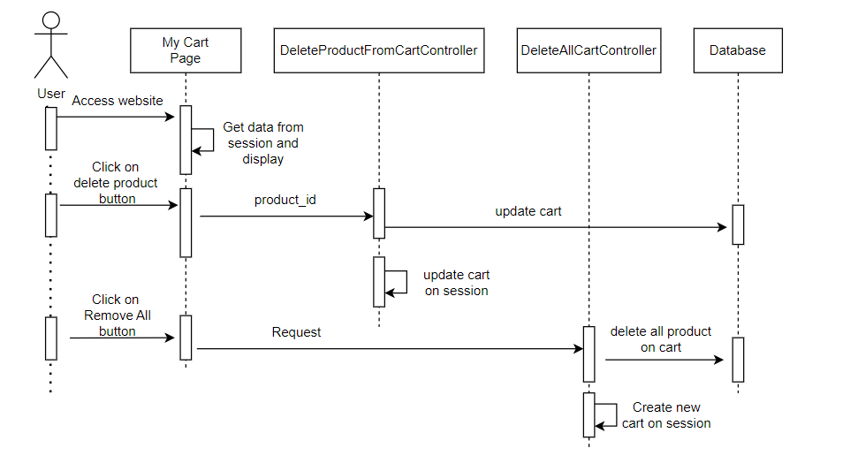

d. Database Queries

//delete specific product on cart

DELETE FROM [DBO].[CART]

WHERE PRODUCT_ID = ? AND CUSTOMER_ID = ?

//delete cart by customer id

DELETE FROM [DBO].[CART]

WHERE CUSTOMER_ID = ?

## 12.

a. Class Diagram

b. Class Specifications

#### DBContext

***Class Methods***

|  |  |  |
| --- | --- | --- |
| **No** | **Method** | **Description** |
| 01 | DBContext() | To connect with database |
| 02 | main(String[]) | Call DBContext() |

c. Sequence Diagram(s)

d. Database Queries

## 13. My Cart

a. Class Diagram

b. Class Specifications

#### DBContext

***Class Methods***

|  |  |  |
| --- | --- | --- |
| **No** | **Method** | **Description** |
| 01 | DBContext() | To connect with database |
| 02 | main(String[]) | Call DBContext() |

c. Sequence Diagram(s)

d. Database Queries